Jake Gentry Code Review by Eric Mas
- I can’t open database.
- Will provide a screenshot of error
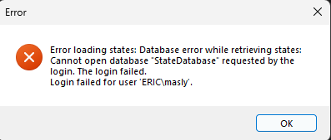
- Form layout is very nice on main is very nice
- Buttons easy to read forgot to add tool tips on main form
- Code is easy to read for the main form just forgot to add comments
- Created a class repository which was a great idea to have all the main classes and methods in one to
- reference to! Also missing comments
- State class coded very well awesome job! Just missing comments
- State Detail form layout is organized as well planned!
- code is easy to read but missing comments

